Year 3 Final Group Project

Game Concept Design

BSc Virtual Reality and Games Design

Caleb Griffin (GRI18006287)

Conrad Smith (SMI18000359)

Craig Zeki (ZEK21003166)

Jon Fieldhouse (FIE20004492)

Table of Contents

Overview 3

Marketing Version: 3

Management Team 3

User Description 4

Gameplay Features / Underlying Magic 5

Marketing Version: 5

Timeline 6

Justification of Design 6

Value Proposition 7

Competitive Analysis 7

Design Limitations 7

Business Model 8

Go-To-Market Plan 9

Financial Projections and Key Metrics 10

Cost Calculation 11

Expected Timeline 11

Estimated Revenue 11

Estimated Costs 12

5 Year Forecast - Net Profit 14

Return on Investment (ROI) 14

Current Status 15

Project Next Steps 15

Possible Expansions 17

References 19

# Overview

Ragdoll Riot: Construction Chaos is a 2D party game with ragdoll physics. Players must collaborate to achieve the group objective within the time limit. Additionally, they should try to accomplish their individual objectives to earn points. If the group objective remains unfinished by the end of the round, no one receives any points.

### Marketing Version:

Get ready for Ragdoll Riot: Construction Chaos, the ultimate 2D ragdoll physics-based party game that will have you and your friends in stitches! Work together in each round to complete the epic group objective before time runs out. But wait, there's more! Rack up points by conquering your own thrilling objectives along the way. Beware, though—if the group objective isn't nailed down by the end of the round, no one gets any points! Get ready to unleash your inner chaos and laughter in Ragdoll Riot: Construction Chaos!

# Management Team

Our management team is comprised of a talented and dynamic group of individuals who bring diverse skills, expertise, and a shared passion for excellence to our company. Together, we form a powerhouse that is poised to drive our company's success.

Caleb, our experienced developer, possesses a wealth of expertise in game development across various platforms. With a strong educational background and a proven track record in delivering high-quality projects, Caleb's technical prowess and dedication to perfection ensure that our games are top-notch.

Craig, our skilled lead developer, leads our development efforts with precision and ingenuity. With a remarkable ability to guide teams, his expertise in C# and Unity development empowers us to create innovative and immersive gaming experiences that captivate our audience.

Conrad, our talented lead artist, has a keen eye for aesthetics and an uncanny ability to bring ideas to life. With a mastery of pixel art and concept development, Conrad's artistic vision and attention to detail ensure that our games are visually stunning and captivating.

Jon, our marketing lead, may be new to the marketing field but brings invaluable expertise in game development and a collaborative mindset to the table. Jon's commitment to excellence, coupled with his dedication to learning, allows us to devise effective marketing strategies that resonate with our target audience.

As a team, we embody the spirit of collaboration, innovation, and unwavering dedication to delivering exceptional results. Our diverse backgrounds and expertise converge to form a collective force that propels our company forward.

Together, we are poised to make a lasting impact in the gaming industry, creating games that entertain, inspire, and delight players worldwide. Our management team is driven by a shared vision and a common goal: to create extraordinary gaming experiences that leave a lasting impression.

# User Description

In order to understand who our audience is and how to reach them, we need to identify target demographics and how to market to them. By drawing up some data for analysis we can try and uncover key demographics within a larger group of users that our project might appeal to.

Construction Chaos is designed to be fun for players of all ages and to reflect this, we wanted a user group whose ages sat at the edges of who we believe will enjoy our game – an idealised demographic of sorts.

User Age Groups 
• 12-18 •1825 •25-35 • 3550 

From the weekly playtimes we can see that most of our audience spends an average time of 8-12 hours gaming per week. Construction Chaos has been designed to have short, punchy rounds taking a few minutes each and totalling 20-25 minutes for a play session. We hope the pick-up-and-play action seems attractive to players who appreciate that the game doesn't eat too much into their gaming time.

User Weekly Playtime 
• 4-6 • 6-8 
.810 •1012 •12+ 

The users’ preferences in genres was also provided, which has been tallied below. The data shows that Multiplayer/Co-Op games are the most popular with our users. Perhaps this is because while some players prefer action/adventure to an FPS/Shooter, both users might enjoy Multiplayer and Co-Op games.

User Interest in Genres 
Sports 
party 
Multiplaye r/Co-Op 
F B/S hooter 
Platformer 
Action/Adventure 

The result of analysing this data allows us to find the most effective methods to reach our audience, based on which demographic users belong to. Identifying the best way to market this project to the largest potential audience will increase our chances of catching on within the gaming community and successfully.

# Gameplay Features / Underlying Magic

Our game offers a unique blend of styles, themes, and mechanics never before seen in a commercial release. Unlike other ragdoll games, which typically use 3D physics, our game stands out by utilizing 2D ragdoll physics. This opens up fresh and captivating ways for players to interact with objects and each other. Additionally, our game features a distinctive combination of ragdoll characters and pixel art, giving it a visually striking appearance that sets it apart from competitors.

The core gameplay of Construction Chaos revolves around collaborative efforts to achieve a group objective. Players must work together to bring specific items to the goal zone in each level. However, individual players also have their own objectives to complete in order to earn points. The more objectives they fulfil, the more points they accumulate. Adding a twist, if the group objective remains unfinished by the end of a round, no player will receive any points.

Our game strikes a balance between competition and cooperation. While players must collaborate to achieve the group objective, they are also vying against each other to earn the highest number of points. This unique blend of competitive and cooperative gameplay provides a fresh experience that sets our party game apart from others in the genre.

### Marketing Version:

Get ready to experience a game like no other! Our game is a wild mix of styles, themes, and mechanics that will blow your mind! We've taken ragdoll gaming to a whole new level by introducing 2D ragdoll physics, something you won't find in your average game. Prepare for a rollercoaster of hilarity as you interact with objects and each other in totally unexpected ways!

But that's not all. We've spiced things up even further by combining ragdoll characters with vibrant pixel art, creating a visual feast that will leave you mesmerized. Our game is a true standout among its competitors, guaranteed to grab your attention and keep you hooked for hours on end.

Now, let's talk gameplay. Construction Chaos is all about teamwork and achieving the ultimate group objective. Picture this: you and your friends working together, laughing your heads off as you try to bring specific items to the goal zone. But hold on, there's a twist! Each player also has their own objectives to complete, racking up points along the way. The more objectives you conquer, the more points you earn. Oh, and here's the catch - if you fail to complete the group objective by the end of a round, none of you get any points! It's a frenzy of fun and strategy, keeping you on your toes for six exhilarating rounds!

Get ready to unleash your competitive spirit while fostering teamwork. Our game is the perfect balance of collaboration and competition, delivering an electrifying party experience like never before. It's time to join the chaos and discover a whole new world of gaming excitement!

# Timeline

Going into this project, we planned out what should be taking place each week in order to deliver within the time available to us. This was very helpful in keeping the team coordinated, with the intention of reaching milestones together and focussing on a few key goals.

Tasks 
Design 
Development 
Testing 
Promotion 
Release 
Marketing content 
Maintenance 
ease marketing content 

By taking this approach, we were able to support each other where necessary to keep development moving forward at a consistent and effective pace.

# Justification of Design

The team was tasked with creating a multiplayer game of some kind for this project. We took time to consider our options but decided early on that we would be developing a game that has online multiplayer. This decision was justified by how popular this category of games continues to be. It would also provide an excellent learning opportunity, dealing with the complexities of creating the online environment. Other features identified early into the project’s life span, include the ragdoll mechanics/physics and the cartoonish art-style, and both facilitate a fun experience when playing Construction Chaos.

# Value Proposition

We believe the value in our product is being able to have fun with your friends in similar style to other competitors but for a fraction of the cost. Our game isn't restricted to a specific platform and is thus relatively easily accessible and for a small entry fee, players can have hours of fun. Other games in the same genre have seen great success by employing game mechanics that pit players against each other in games of lies and deception such as Among Us, in the cooperative madness found in the Overcooked games and in direct combat in games like Rubber Bandits.

Construction Chaos, however, offers a brand-new experience in the multiplayer party game arena. By combining the concepts of cooperation and competition, we have crafted a new subgenre that we like to call "coop-etition" (a term that has been used to describe a business strategy since the 1990s), players must work together to achieve a group objective (normally bringing a list of certain items to a location in the level) but at the same time they have their own tasks to worry about (which usually involve tracking down a certain item and performing a specific action with that item). The more individual tasks a player successfully completes, the more points they earn. Here's the catch: if the group objective remains unfinished at the end of the round, no player receives any points.

This dynamic transforms the game into a strategic challenge of time management. Players must decide whether to pursue additional tasks for extra points or contribute towards the group objective to avoid losing all points.

We firmly believe that this innovative subgenre of party games, brought to life by the unique mechanics of "Construction Chaos," presents an exciting opportunity in the current market.

# Competitive Analysis

The pricing data attached (Appendix L - Multiplayer Game Market Analysis) that covers many popular multiplayer games across multiple platforms. The only game on here that has a similar price point, is the ever popular Among Us. We can therefore confidently market Construction Chaos from this price point, presenting a lot of value to fans of multiplayer.

The relatively low, entry price point will also give us room to increase the cost slightly (£1 - £4 increase) as more features are added to the game - see 'Project Next Steps'. This cost increase should be tolerated by the market as it would still be lower than competing games.

The analysis of the multiplayer games (Appendix L - Multiplayer Game Market Analysis) also shows clearly that the target platforms should be PlayStation, PC, Xbox, and Nintendo Switch. The game design must allow for at least PC and console input controls to stay competitive.

# Design Limitations

When comparing our concept to other existing multiplayer or coop party games there are some limitations that can crop up that should be addressed. One big example is that we don't currently plan to have any way for players to be able to connect anonymously or have public lobbies that anyone can join. This is mainly due to the time and resource limits that we are facing with the development of this project, but another factor is the communication that is required to be successful at the game. Because the players are completing an objective together, being able to communicate effectively lends to a huge advantage in being able to actually complete said objective and in turn makes the experience much more fun. Therefore, if players are connecting anonymously or through public lobbies then either this communication is impossible, or we have to implement our own voice chat or other communication options which can create a lot of headaches around safeguarding and privacy concerns that are out of the scope of this project.

Another limitation of this current design is the lack of accounts or permanent data storage. This is another common feature amongst other popular party games that allow players to gain long lasting rewards based on their performance in the game and that are connected to an account which is fixed between sessions. This can provide a lot more incentive for players to keep coming back to games to improve and play more, especially when these rewards are connected to other e-shop type systems such as cosmetic items or small "boosts" given to them in the game. Once again, I think that this is out of the scope of this project and would be something to seriously consider for the future.

# Business Model

We have identified our target audience to be quite a large demographic. While the average gamer is reportedly 35 years old (Jovanovic, 2022), gaming is popular with people both younger and older than this. The table below shows the popularity of gaming with different age groups in the United States according to data reported by Stojanovic (2021).

Popularity of Gaming in the United States 
Under 18 •18-34 • 35-44 

Construction Chaos will be available through itch.io, a platform we are confident in launching on as research shows (Jovanovic, 2022) that over 1.8 billion people are PC gamers and according to Yanev (2022), 56% of the most frequent gamers play multiplayer games.

After some consideration, we have decided to try and market this project with a price of £6 for the initial release. This is a relatively small entry fee to what we consider to be great value, multiplayer fun. This low price point gives room to be increased as improved features are added - see section 'Competitive Analysis'.

Additionally, we could provide incentives for players to purchase to Construction Chaos on itch.io, like exclusive in-game items, digital artbooks or early access to future updates. Offering unique content enhances the perceived value and will encourage players to support our game directly on the platform. In the future we will consider alternative revenue streams like merchandise or downloadable content (DLC).

We hope to engage with players and build a community around Construction Chaos by encouraging them to share their experiences with us through social media. Through these platforms, we can engage with the community and excite them by sharing updates, behind-the-scenes content, and gameplay teasers.

Construction Chaos will roll-out regular updates based on player feedback and bug reports. The team will offer timely customer support to address any issues or inquiries promptly. Regular updates not only consistently improve the game's quality but also signal commitment to delivering a great experience. An experience we want the community to enjoy to the fullest.

# Go-To-Market Plan

Leading up to the release of Construction Chaos, the team will be actively preparing marketing content for release on social media platforms, with the intention of reaching out to players and building a community around their engagement and feedback. Through analysis of our user data, we can identify which platform is more likely to reach specific demographics within our target audience.

Instagram is known for its visual content and has a massive user base. According to our research (ViscapMedia), Instagram has the largest potential target demographic of users aged 24-35. This age group represents a significant portion of Instagram's user base, making it an ideal platform to reach this specific demographic. Additionally, 67% of Instagram users fall within the age range of 18-24 years old, indicating a substantial overlap with the desired target demographic.

YouTube is another platform with a substantial user base and a broad advertising audience. Research by Chi (2019) indicates that approximately 20% of YouTube's advertising audience falls within the 24-35 age range. This also happens to be the largest age group on the platform, with both groups 18-24 and 35-44 make up about 15% each. This suggests that YouTube also attracts a significant number of users within the desired target demographic.

Twitter, while popular across various age groups, is reported by Cooper (2019) to be favoured by users aged 18-34. This age range represents the most prominent demographic on Twitter. Therefore, targeting users aged 24-35 on Twitter aligns with the platform's user preferences and can potentially reach a substantial portion of the desired target audience.

By focusing marketing efforts on Instagram, YouTube, and Twitter, which have large user bases and significant proportions of users aged 24-35, we can effectively reach our intended demographic. These platforms provide ample opportunities for engaging with the desired audience and generating brand awareness among users within the target age range. We could also consider running targeted ads or collaborating with influencers who cater to our game's target audience, to further our reach.

It is important to note that the content posted should be catered to each platform. Promotional artwork for example, is well suited to Instagram and Twitter, whereas YouTube and another social media platforms like TikTok, will be better suited to video content. All content used to promote the game across all platforms will point back to our itch page where the game can be downloaded easily.

# Financial Projections and Key Metrics

Based on a survey of "Most played types of games among gaming audiences in selected countries as of January 2021", 73.6% of respondents played "Casual multiplayer games (like Words with Friends) (Statistica, 2021) - See Appendix O - Financials. This is the category which would best fit our genre of game. Using this statistic, combined with the previous data from the section 'Business Model', an estimate of the total audience for our game can be calculated as follows:

|  |  |
| --- | --- |
| Number of PC Gamers (Global) | 1,700,000,000 |
| % of gamers playing multiplayer | 56.0% |
| Number of PC Gamers (Multiplayer) | 952,000,000 |
| % of casual multiplayer game players | 73.6% |
| Number of casual multiplayer players | 700,672,000 |
| Estimated % interested in Construction Chaos | 0.5% |
| Construction Chaos target audience (max) | 3,503,360 |
| Estimated % of target audience captured | 10.0% |
| **Estimated number of target audience captured** | **350,336** |

This value for target audience will be used later to help estimate the financial forecasts.

The detailed financials can be located in Appendix O - Financials and are summarised here.

## Cost Calculation

To forecast the financial performance, the remaining costs need to be understood. Section 'Project Next Steps' details the proposed changes and the associated costs. These costs were calculated using a cost model which details how the below table was derived, stored in Appendix O - Financials.

|  |  |
| --- | --- |
| **Total Labour Costs** | **£ 52,343.70** |
| **Total Setup Costs** | **£ 6,100.00** |
|  |  |
| **Total Costs (excl. Maintenance & recurring expenditure)** | **£ 58,443.70** |
|  |  |
| **Annual Maintenance @ approx. 583 hr / year** | **£ 14,550.00** |

## Expected Timeline

The 5-year look ahead will be calculated, with Year 1 starting in Jan 2023 and including all development work. Note, only remaining development work is shown in the below timeline.

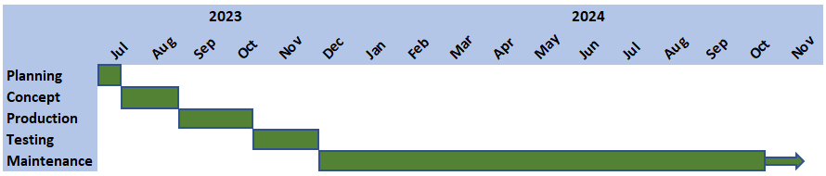

## Estimated Revenue

The 5 year revenue (gross) can be estimated using a conservative adoption rate for obtaining the target audience.

|  |  |  |  |
| --- | --- | --- | --- |
|  | **Assumed target audience size** |  | **Sell price (GBP)** |
|  | **350,336** |  | **£ 6.00** |
|  |  |  |  |
| **Year** | **Adoption rate** | **Units Sold** | **Total Revenue** |
|  |  | **Base App** |  |
| Year 1 | 1% | 3,503 | £ 21,018 |
| Year 2 | 3% | 10,510 | £ 63,060 |
| Year 3 | 5% | 17,516 | £ 105,096 |
| Year 4 | 5% | 17,516 | £ 105,096 |
| Year 5 | 5% | 17,516 | £ 105,096 |

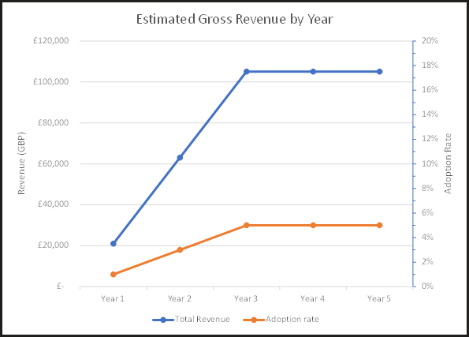

## Estimated Costs

There will be some standard costs which have to be applied year-on-year.

|  |  |  |  |
| --- | --- | --- | --- |
| **Recurring Expenditure** | Development Environment | £ 4,500.00 | 4 x Unity Licenses |
|  | Itch.io Fee (5%) | £ 0.30 | 5% of £6 - per unit sold |
|  | Unity Relay Fees - CCU | £ 0.13 | per CCU > 50 per month |
|  | Unity Relay Fees - Bandwidth | £ 0.13 | per GB > 150 per month |
|  | 25k Ad Impressions | £ 135.00 | per week (based on Facebook cost of $7.19 CPM) |

Itch.io can be free, however it is the belief of this team that we should support Itch.io by providing 5% of sales.

|  |  |  |
| --- | --- | --- |
| **Year** | **Units Sold** | **Itch.io Cost** |
| 1 | 3503 | £ 1,050.90 |
| 2 | 10510 | £ 3,153.00 |
| 3 | 17516 | £ 5,254.80 |
| 4 | 17516 | £ 5,254.80 |
| 5 | 17516 | £ 5,254.80 |

In addition to the Itch.io cost, there is a cost for the use of the Unity Network Service - Unity Relay. This cost is dependent upon many factors. An estimate of this is shown here.

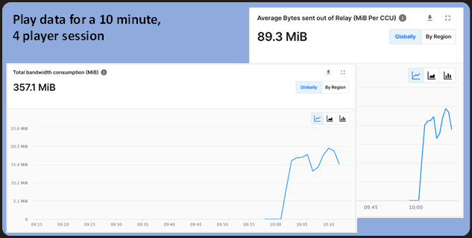

|  |  |  |  |  |  |  |  |  |  |
| --- | --- | --- | --- | --- | --- | --- | --- | --- | --- |
| **Year** | **Number of Units Sold** | **Cumulative Number of Players** | **Number of concurrent players** | **Cost of concurrent player > 50 (per month)** | **Monthly Data consumption (MB)** | **Free Data (cap in MB)** | **Net Data (MB)** | **Cost of data (per month)** | **Total Cost (per month)** |
| 1 | 3,503 | 3,503 | 351 | £ 38.53 | 469,227 | 150,000 | 319,227 | £ 40.86 | £ 79.39 |
| 2 | 10,510 | 14,013 | 1,402 | £ 173.06 | 1,877,041 | 150,000 | 1,727,041 | £ 221.06 | £ 394.12 |
| 3 | 17,516 | 31,529 | 3,153 | £ 397.18 | 4,223,310 | 150,000 | 4,073,310 | £ 521.38 | £ 918.57 |
| 4 | 17,516 | 49,045 | 4,905 | £ 621.44 | 6,569,578 | 150,000 | 6,419,578 | £ 821.71 | £ 1,443.15 |
| 5 | 17,516 | 66,561 | 6,657 | £ 845.70 | 8,915,846 | 150,000 | 8,765,846 | £ 1,122.03 | £ 1,967.72 |

|  |  |  |
| --- | --- | --- |
| **Cost of concurrent players > 50 (per year)** | **Cost of data (per year)** | **Total Cost (per year)** |
| £ 462.34 | £ 490.33 | £ 952.67 |
| £ 2,076.67 | £ 2,652.74 | £ 4,729.41 |
| £ 4,766.21 | £ 6,256.60 | £ 11,022.81 |
| £ 7,457.28 | £ 9,860.47 | £ 17,317.75 |
| £ 10,148.35 | £ 13,464.34 | £ 23,612.69 |

## 

## 

## 5 Year Forecast - Net Profit

Based on an assumed 20% of 1 Full Time Engineer (FTE) year-on-year maintenance effort, the ongoing maintenance cost can be calculated to be £14,600 per year.

Utilizing this and the ongoing, recurring yearly costs (from above), the final cost walk can be created.

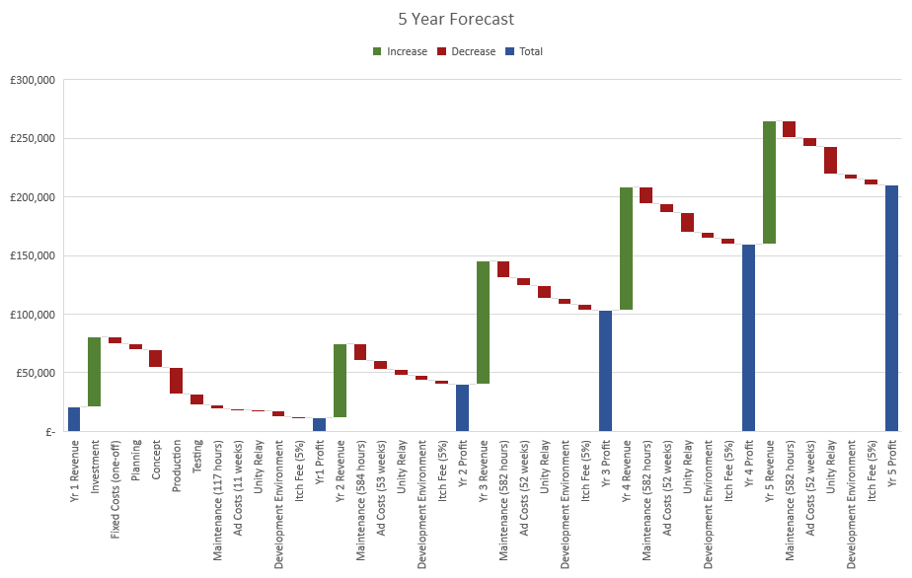

## Return on Investment (ROI)

To protect the existing shareholders (team members) the investment share should be limited to ensure control of the company remains with the original team. This would cap the maximum investment share of the business at 49%. Based on this, a share of 40% and a required, one-off, up front, investment of £60,000.00 the 5-year ROI can be summarised as:

|  |  |  |  |
| --- | --- | --- | --- |
| **Investor Share** | 40% |  |  |
| **Investor GBP** | £ 60,000 |  |  |
|  |  |  |  |
| **Year** | **Net Profit** | **Investor Profit Share** | **ROI** |
| 1 | £ 11,661 | £ 4,664 | 8% |
| 2 | £ 40,583 | £ 16,233 | 27% |
| 3 | £ 103,332 | £ 41,333 | 69% |
| 4 | £ 159,785 | £ 63,914 | 107% |
| 5 | £ 209,944 | £ 83,977 | 140% |

This results in the investor breaking even in year 3 when 100% of the £60,000 investment will have been returned, with profit. If the forecast holds, the investor will receive £153,121.83 in profit after the 5 years - an ROI of 3.55.

This growth of ROI would not expect to continue much past 5 years as the game relevance dies down. However, as discussed in section 'Possible Expansions', and if these financial forecasts are correct, there could be opportunity for re-investment into multiple spin-off games - ensuring continued growth of the initial investment.

# Current Status

The current status of the project is that we have released a fully working build of the game which we consider to be a good representation of the initial idea and vision that we had for this project. We had hoped to have more levels working in the final game, but this is something that can be discussed in the next steps and expansions for this project as we have enough levels to give players a taste for the gameplay and content of the game. That being said, all of the mechanics that we originally planned for the game have successfully made their way into the playable version with players able to interact with each other and with objects in the scene to complete both individual and group objectives. The networking in the game works as we had intended with players able to connect together in a game over the internet without needing to be in the same room or on the same local network, this continues to reinforce the social aspects of this game as it opens up the game to be accessible to more people.

# Project Next Steps

The following next steps are proposed to improve the project. Estimated costs are shown, along with how these changes are forecast to benefit the player (buyer), leading to continued sales. The next steps are intended to be individual, so any combination of these could be chosen.

|  |  |  |  |  |
| --- | --- | --- | --- | --- |
| **Improvement** | **Effort**  **(Man hours)** | **Est. Cost (GBP)** | **Benefit**  **(Increased…)** | **Notes** |
| Client-side prediction to remove lag | 1200 | £ 25,955.56 | Player engagement, interaction and replayability | Client-side prediction would vastly improve the game experience for connected client players. This would increase engagement and length of interaction, and indirectly increase replayability. |
| Additional rounds (18 additional rounds) + option to configure game length | 180 | £ 3,893.33 | Player engagement, interaction and replayability | Effort for this is highly optimized due to already created level component design tools such as the Objective Manager, Platform Arranger, Chain Maker, etc.  Having varied rounds per game will greatly increase player interest and replayability. |
| Music and Sound Effects | 80 | £ 1,730.37 | Player engagement | This is enabled by client-side prediction. Without this sound effects would not be synchronised with the player inputs. |
| Differentiator between group and individual objectives or their timers. E.g., do not have a group objective for the first 1 min of the game. | 80 | £ 1,730.37 | Player replayability | Driven by player feedback - to allow individual objectives to be completed and drive competitive scores. |
| Player controls in-game tutorial | 120 | £ 2,595.56 | Player interaction | Organic / Just-In-Time tutorial - When the player joins the lobby, the movement controls are shown to the player, then as they approach an object (crate or swing) the controls to pick up or swing are shown. |
| Player character break apart feature | 40 | £ 865.19 | Player engagement | The player's character will break apart when hitting into solid objects too quickly. The player will 'reassemble' upon keypress. |
| Additional round interactable items, e.g., 'Industrial fan' upwards thrust zone. | 400 | £ 8,651.19 | Player interaction and replayability | Offer more choice to the player of how to complete levels, adding to complexity and increased competition between players. |
| Additional mid-ground and back-ground assets | 200 | £ 4,325.93 | Player engagement | Increased atmosphere and varied environment. |
| Improved menu background transitions | 40 | £ 865.16 | Player engagement | Minor quality of life change to make the menu system feel more polished. This is one of the first things the player sees when loading the game - first impressions. |
| Animated clouds to be improved | 80 | £ 1,730.37 | Player engagement | Minor quality of life change to avoid the clouds from clipping through each other due to varying speeds while on the same layer. |
| Bug fixes and ongoing support for 1 year | 582 | £ 14,600.00 | Player engagement, interaction and replayability | Ensure continuous improvements to the game in its initial stages of launch. This will keep the community engaged, interested, and satisfied as new rounds are rolled out, any bugs / issues can have rapid responses, etc. |

* Costs estimated in Appendix O - Financials using a cost model.

In addition to the changes already identified in the table above, during the alpha development there was an alternative control scheme created which we would like to explore more and compare to the existing one. This alternative control scheme allows the player to adjust their momentum in a simpler manner as well as the ability to grab and kick items, however this type of scheme would mean removing the ‘ragdoll’ type features of the player. This alternative control scheme can be viewed in Appendix Q - Alternative Control Types. If we were to implement such a scheme, it is estimated to take 120 hours (a rough cost of £2600).

# Possible Expansions

The original game could easily lead to different themed environments, but with similar interaction / controls. E.g., Kitchen Chaos, where the objects involved could be pots and pans, cutting boards, knifes, etc. Other theme ideas could be Space Station Shenanigans, Haunted House Hijinks and Toy Factory Frenzy. It could be possible for Space Station Shenanigans to have slightly altered physics to allow for more interesting low gravity game play and this could lead to a different set of methods that the player would have to use to complete the objectives - offering a refreshing change to the similar controls as the other games.

Alternatively, the base game could be easily expanded upon through the inclusion of more game modes such as a game mode which focuses more on cooperation or competitiveness in which players have only team or group objectives, but the objectives would be much harder and far easier to sabotage from one another. Furthermore, these maps could have objects which force the player into a stun state meaning that they could be disarmed while they are all doing an individual objective but using the same objects.

On the other hand, a purely cooperative mode could include players needing to scale large maps using objects that other player needs to hold or throw making an experience similar to battle block theatre.

# References

Chi, C. (2019). *2019 YouTube Demographics [New Data]*. [online] Hubspot.com. Available at: https://blog.hubspot.com/marketing/youtube-demographics.

Cooper, P. (2019). *28 Twitter Statistics All Marketers Should Know in 2019*. [online] Hootsuite Social Media Management. Available at: https://blog.hootsuite.com/twitter-statistics/.

Jovanovic, B. (2022). *Gamer Demographics: Facts About the Most Popular Hobby*. [online] Dataprot. Available at: https://dataprot.net/statistics/gamer-demographics/.

Statistica (2021). *Favorite video game types worldwide 2021 | Statista*. [online] Statista. Available at: https://www.statista.com/statistics/371020/consumer-preferred-video-game-types/ [Accessed 6 Jun. 2023].

Stojanovic, M. (2021). *15 Interesting Gamer Demographics in 2021*. [online] Playtoday. Available at: https://playtoday.co/blog/stats/gamer-demographics/.

ViscapMedia (n.d.). *Understanding Instagram Demographics by Industry: Know How to Target Users the Right Way – Viscap Media*. [online] ViscapMedia. Available at: https://viscapmedia.com/articles/instagram-demographics/.

Yanev, V. (2019). *Video Game Demographis - 25 Powerful Stats for 2020*. [online] TechJury. Available at: https://techjury.net/blog/video-game-demographics/.